

DOONFIRESERVICES

##### Proprietary and confidential for internal use only



REGISTERED OFFICE: Bhatt Niwas, Lane No.2, House No. 2,

Tarun Vihar Mothorawala Road, Banjarawala , Dehradoon, Uttrakhand - 248001.

CORPORATE OFFICE :713, GTM lavana Haridwar Road , Dehradun

Uttrakhand**–** 248001

Phone No: 9412051889, 9897574

MAIL: [doonfireservices@gmail.com](mailto:doonfireservices@gmail.com) Web: [www.doonfireservices.com](http://www.doonfireservices.com/)

53, 7351003733

All rights reserved. No part of this document may be reproduced or transmitted in any form or by any means, electronic or mechanical, including photocopy, recording, or any information storage and retrieval system, without permission from Doon FireServices.

**About Us**

Doon Fire Services (DFS) is one of the constituents of 3B Group of companies , a large Corporate group located at Uttrakhand and Delhi. 3B Group is a group of visionary professionals associated from Industrial, Corporate, Safety, and

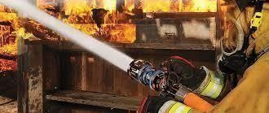

higher management educational

background people. It was established with the vision to create for excellence in society and provide best holistic approach towards its goal.Doon Fire Services is one of the leading Fire and Safety company having expertise in fire and safety solution since last ten years.

During 14 years of its existence we have installed fire and safety solution to several University/School/Colleges, Hospitals, Hotels, Factories, Housing Societies as well as big corporate. DFS was established on dated 31st December 2007 and the company has started its own business activity from the same year. DFS was founded to spearhead the group’s foray into the burgeoning Fire Safety provider market.



The company has been constantly working towards achieving its objective of providing quality end- to-end solutions in Fire and Safety to its customers who range from individual, corporations to large Pvt/Public and Govt Authorities.

**Overview**

Doon Fire Services is a part of 3B group which has diversified interests in the corporate arena. It was founded to spearhead the Group’s foray into the burgeoning corporate solutions market.

**DFS** is constantly working towards achieving its objective of providing quality end- to- end solutions and consultancy services to various category of its segment range from rural to urban and town to metros.

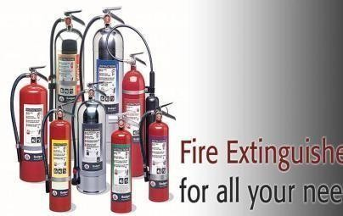

**DFS** is a company having dynamic professionals with extensive experience in all aspects of Fire Safety to big pvt/public and Government Sector.

**Hydrant systems**

DELIVERY HOSE

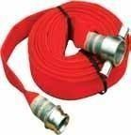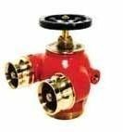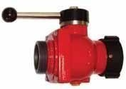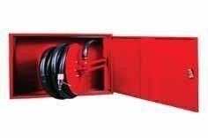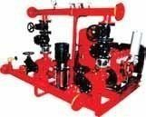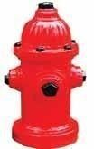

|  |
| --- |
|  |
|  |
|  |
|  |
|  |

HYDRANT VALVES

HYDRANT FIRE PUMP

HOSE REEL WITHCABIN

## MISSION



* To bring innovation in Fire Safety Protection.
* To develop anddeliver customized Fire Safety solutions of the highest quality and reliability at reasonable cost and without delay.
* To be a reliable and economical provider of Fire Safety services.
* To develop and nurture high caliber skills in our fields and to foster and environment that encourages

professional excellence.

* To develop and maintain long term relationships withcustomers.

**Guiding Principles**

#### Pursuit of excellence

We strive for the highest professional standards in our work and aim to be the best in everything we do.

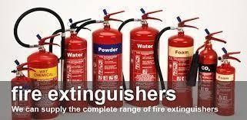

#### Customer Orientation

Our customers come first because they are the reason we are in business.

##### Business Ethics and Integrity

We strive for fairness in all our business and working relationships.

##### Team Work

We work with pride as a team to achieve success together.

Quality consciousness

Quality is a way of life. We are striving to achieve quality certifications as rapidly as possible.

# SERVICES

We are Fire Safety solution provider professionals. DFS offers seamless Fire Safety services which include but are not limited to supply and installation of Fire Safety material but educating our customer to help them fire safety audit in their organization. We provide

complete Fire Safety Solution from AMC to provide Fire man to the

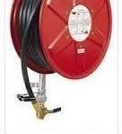

organization and Fire consultancy and design for their business place.

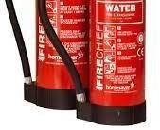

**Our Strength**

* We are committed to provide best quality services Products reliability for the large business as well as Govt. Authority.
* Decision based on analysis of the market returns and its fitness with present and future strategy.
* Able to perform stand alone or with a team.
* Proven ability to deal with large technology issues. Quality emphasis through attention to detail. Inherent desire to get the Project done and Customer focused.

# Value Proposition

DFS integrates People, Process and Technology to deliver innovative solutions to a Customer problem. These solutions are backed by the highest standards of quality.

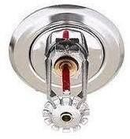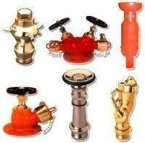

Clientele

### University/School/College

* Graphic Era
* Mount Litera School
  + Swami Rama Himalaya University
  + Kukreja Institution
  + Shemford School
  + Hope Homes
  + U K Technical University
  + Shri Guru Ram RaiSchools
  + CBSE Building
  + Wynberg Allen School Mussoorie
  + Manava Bharati India International School
  + Doon University
  + Asian School
  + Eco Global
  + Shivalik College of Engineering
  + DAV
  + St. Joseph
  + Brookyln School
  + Acacia Public School
  + Sunrise Academy
  + Charmwood Public School
  + St. Anne School
  + Kendriya Vidyalaya
  + Pine Hall School
  + Seven Oaks School
  + Vivekanand School
  + Doon International School
  + Jaswant Modern School
  + Social Baluni Institute

**Airport/HeliPad**

* + - Dehradun Helipad
    - Pithoragarh Helipad
    - Chinyalisod Helipad

**Hotels/Motels/Guest Houses/ Restaurant**

* + Beach Hotel Mussoorie
  + MJ Residency
  + Amber Palace
  + S J Residency
  + Hotel Arnavya
  + Hotel Kamla Palace
  + Aerodine multicuisine restro
  + Amaya Resort
  + Hotel Royal Inn
  + Butola Guest House
  + Golden Leaf Restaurant
  + Drona Guest House
  + Benison Guest House
  + Hotel Viceroy
  + Hotel Sunrise
  + Hotel Forest Avenue

**Corporates**

* + Bharti Airtel Ltd
  + Asian Paints
  + Rusna Ltd
  + TCS Ltd
  + Amber Enterprises
  + Aquamall Water Solutions Ltd. Lal Tappar
  + Mahindra Automobile DPM
  + Kumar & Sons
  + Highway filling Station
  + Brij Mohan Filling Station
  + Aggarwal Filling Station
  + Jeet Arcade
  + V.S. Builtech
  + Vestige Marketing Pvt Ltd.

**Shopping Complex/ Malls**

* + Classic Business Centre
    - Astley Tower
    - Rajveer Chadda Mall
    - Sunil Dixit Commercial Complex
    - TCJ Mall
    - MDDA Complex (GTM Food and Entertainment)
    - Carnival Cinema
    - Easyday

**Auditorium**

* + - * Govt Auditorium Dehradun

HOUSING SOCITIES

* + - Mahalaxmi Buildwell
    - Bhagirathi Apartment
    - Pratham Valley
    - GTM Forest & Hills Apartment
    - Platinum Paradise
    - Hansmukhi Project
    - Umax Projects- Air Force Naval Officer Residence
    - Windlass River Valley
    - Eastern Arch
    - Aradhana Greens Nalapani
    - Pashupati Heights
    - Foothill Premium Apartment Mussoorie Road
    - Woodland Apartment Mussoorie
    - PC Treasure Valley
    - Pacific estate
    - S.A BUILTECH
    - Rajpur Greens

Hospitals/Nursing Home

* + - Mahant Indresh Hospital
    - CMI Dehradun
    - Himalaya Hospital
    - City Heart
    - Kalindi Hospital
    - Life Line Hospital
    - Padmavati Nursing Home

**Govt Clients**

* + - * PWD
      * UPRNN
      * Peyjal Nigam
      * Sidcul
      * Rajya Abhilekhagar
      * Uttarakhand Gramin Bank
      * Power Grid
      * S.P.N.G
      * UPCL
      * THDC hospital B.Puram
      * Govt. polytechnic Gopeshwar/ Ranipokhari

**Factories**

* Vamso Infotech
* Globus Info ComAmar Remedies Ltd
* ABC Bearing Ltd
* Shahnaj Husain
* Sri Sri Ayurveda Kotdwar
* Signature Chemical
* Fleix Impex
* Balaji Leather Industries.
* Aastha Packaging.
* Ishana Nutraceuticals.
* Addon Industries
* Indian Extrusions.
* QH Talbros Unit IISelaqui.
* Habib Cosmetic Pvt.Ltd.
* Campus Active wear Pvt.Ltd.
* Chemical Systems Technologies India Pvt.Ltd.
* H20 Mineral Water Pvt.Ltd.
* QH Talbros- Langa Road.
* Greatech Telecom Technologies Pvt.Ltd.
* Kaynes Technology India Pvt.Ltd.
* Tirupati LPG Industries Pvt.Ltd.
* Fillmatic Packaging Systems.
* Biological E Limited.
* JMD Footwear Unit-II.
* IPCA
* IMSI
* Datalink
* Sara Farms
* Dixicon
* G.N Enterprises.
* Rahman Industries Limited.

**CAMc/AMC**

* Mahant IndreshHospital
* Vana Enterprise Pvt.Ltd.
* AIIMS- Rishikesh
* AVON

*****************************************************

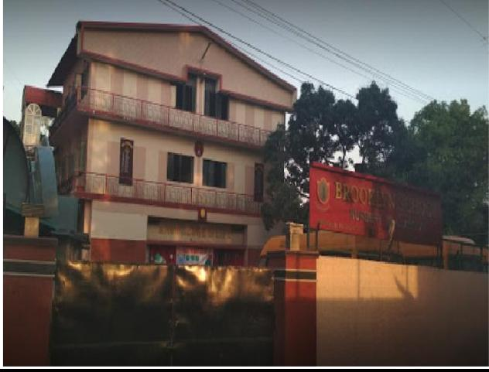

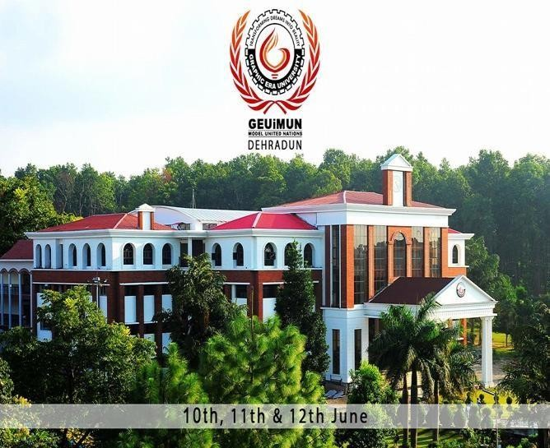

**GRAPHICERAUNIVERSITY BROOKLYN SCHOOL**

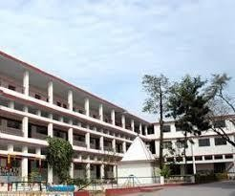

#### ST. JOSEPH ACADEMY DAV SCHOOL

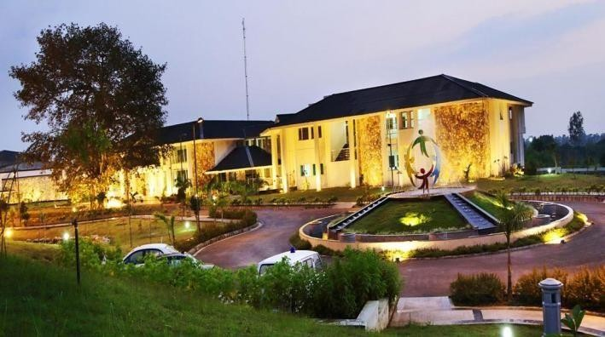

##### ECO GLOBAL SCHOOL

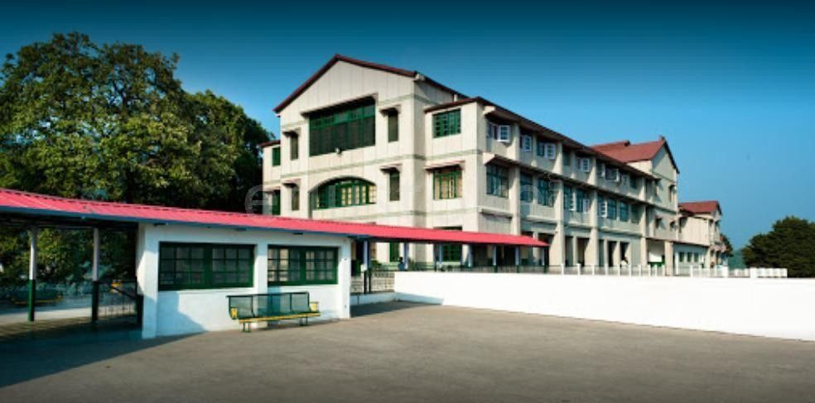 

#### WYNBERG ALLEN SCHOOL SHIVALIK COLLEGE

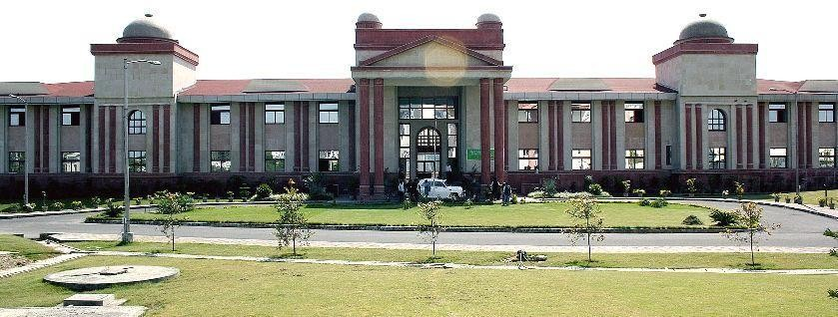

**DOON UNIVERSITY PINE HALL SCHOOL**

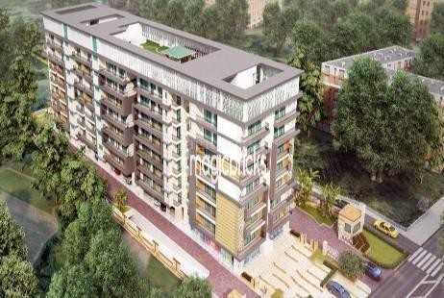**RAJPUR GREENS**

##### PASHUPATI HEIGHTS

 **MADHAV RESIDENCY**

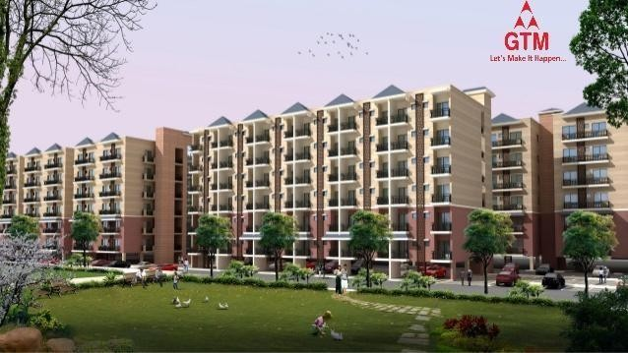 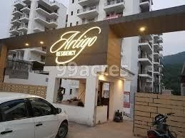

#### GTM FOREST & HILLS ARTIGO

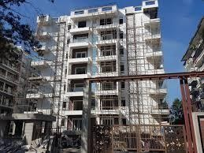

FOOTHILS APARTMENTS VANA

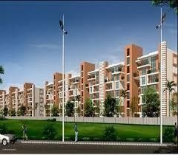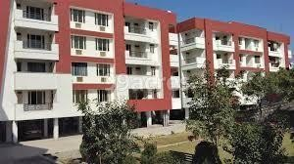

**ARADHANA APARTMENTS PC TRESURE VALLEY**

**AIIMS RISHIKESH**

**SHRI MAHANT INDRESH HOSPITAL**

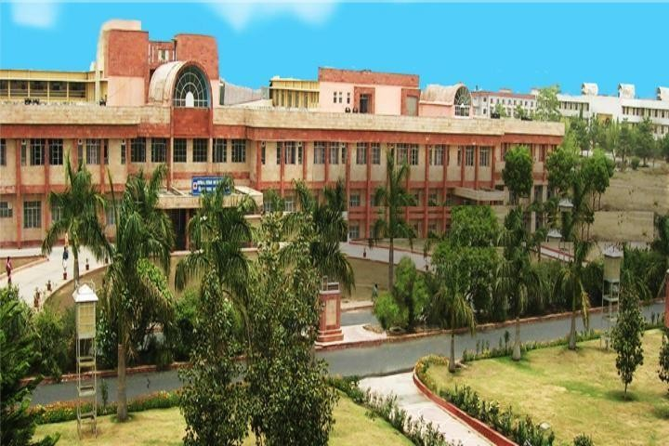 SWAMI HIMALAYAN UNIVERSITY

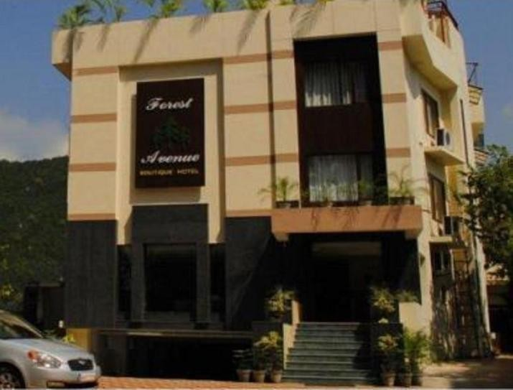 

**HOTEL FOREST AVENUE HOTEL VICEROY INN**

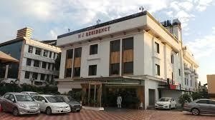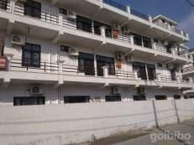

**MJ RESIDENCY BENISON GUEST HOUSE**

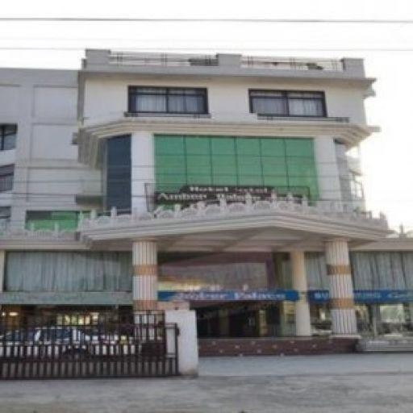 **AMBER PALACE**

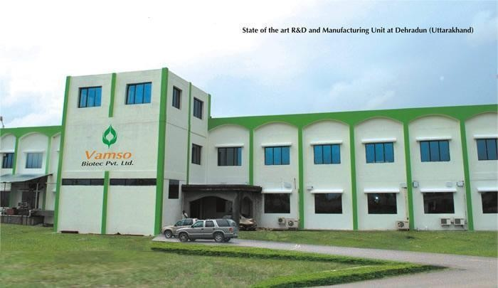 

VAMSO PVT. LTD

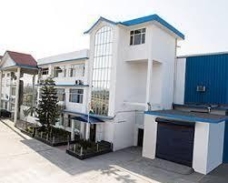

DIXICON **IPCA , SELAQUI**

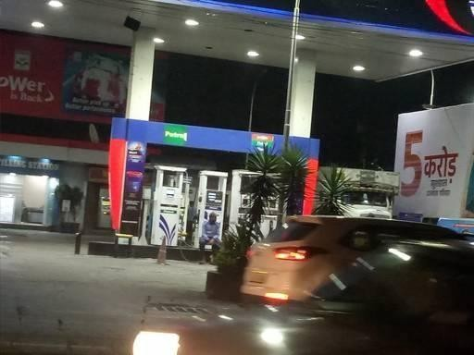

HIGHWAY FILLING STATION

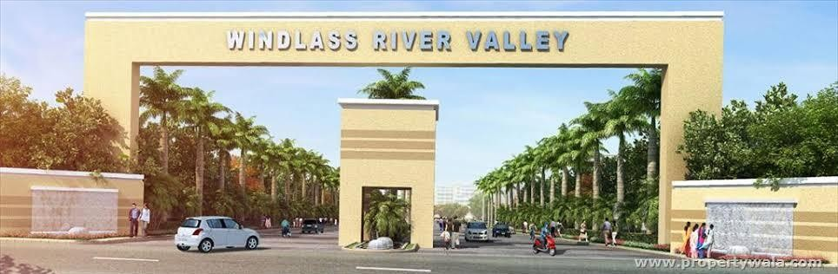

**WINDLASS RIVER VALLEY , KUANWALA**

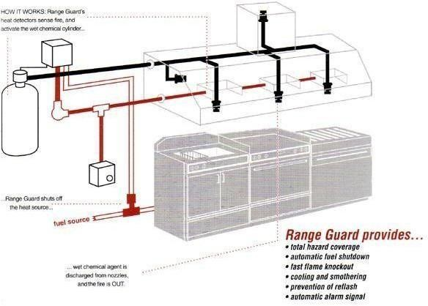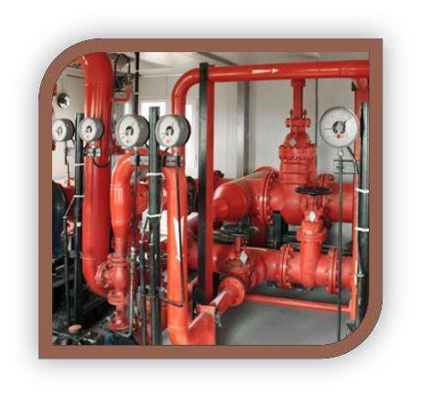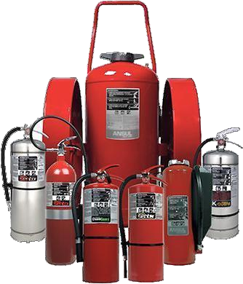

FIRE PROTECTION SERVICES

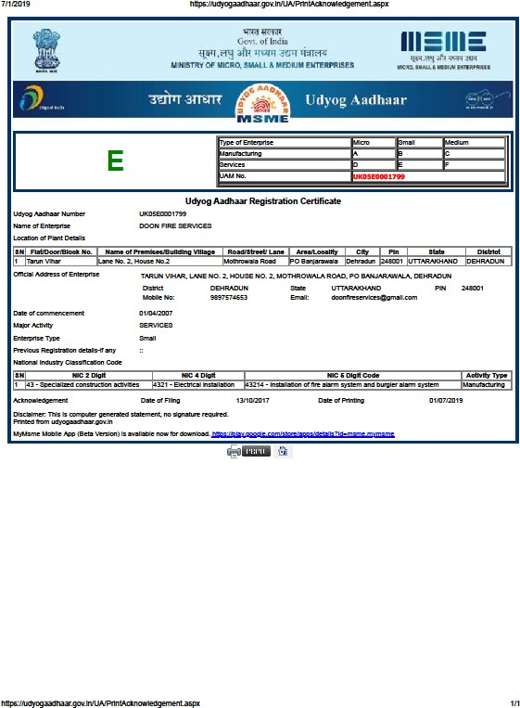

**Ministry of Micro, Small & Medium Enterprises**



EMPLowea” neowoerrz ruND OROAMiBAzioN

( Bozb’ undar tha Ministry af Labour •nd Emptoym•m, Government af Indie)

DGNT •UND CODE NUMBER ffdTlMATlON LETTER

Date : 1B/12/2018

AdAY BHATT

M zzdlzmeoua Ptouiaica¥e AcfL 1852•regaraIng.

Mia Doon Fire Sen/tsee undar Employees’ Provident Fund and

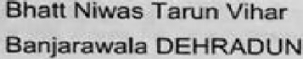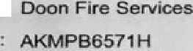

###### or>•s•n••»«s» '« °••» - nurrtbor :

:

- by I enmar0ftcato/numz›er aeued by any sovL autnor‹ty

Page 1 ofy



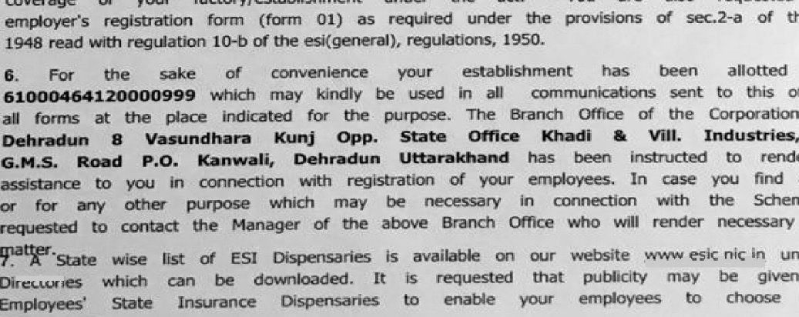

Reg§m$yj 4gtBca

BMPt-OYEE8'8TATEINSURANCE COFiPORA1ON

BbBlonal OBco, Panmdeep Bhawer+. Wing No. 4. Btdvpta1,

C-11 Ropd. wfth a.d

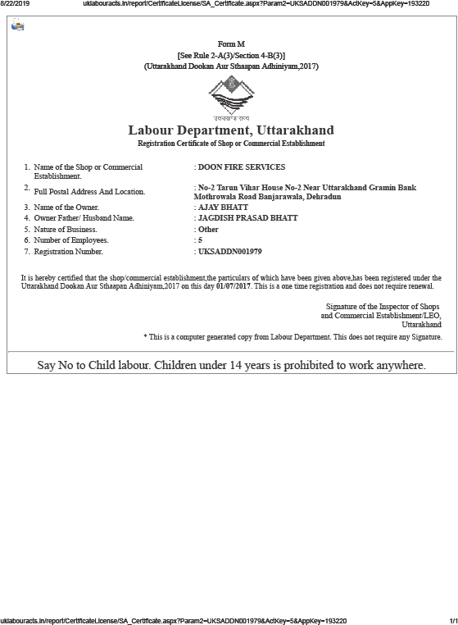

# PURCHASE ORDERS

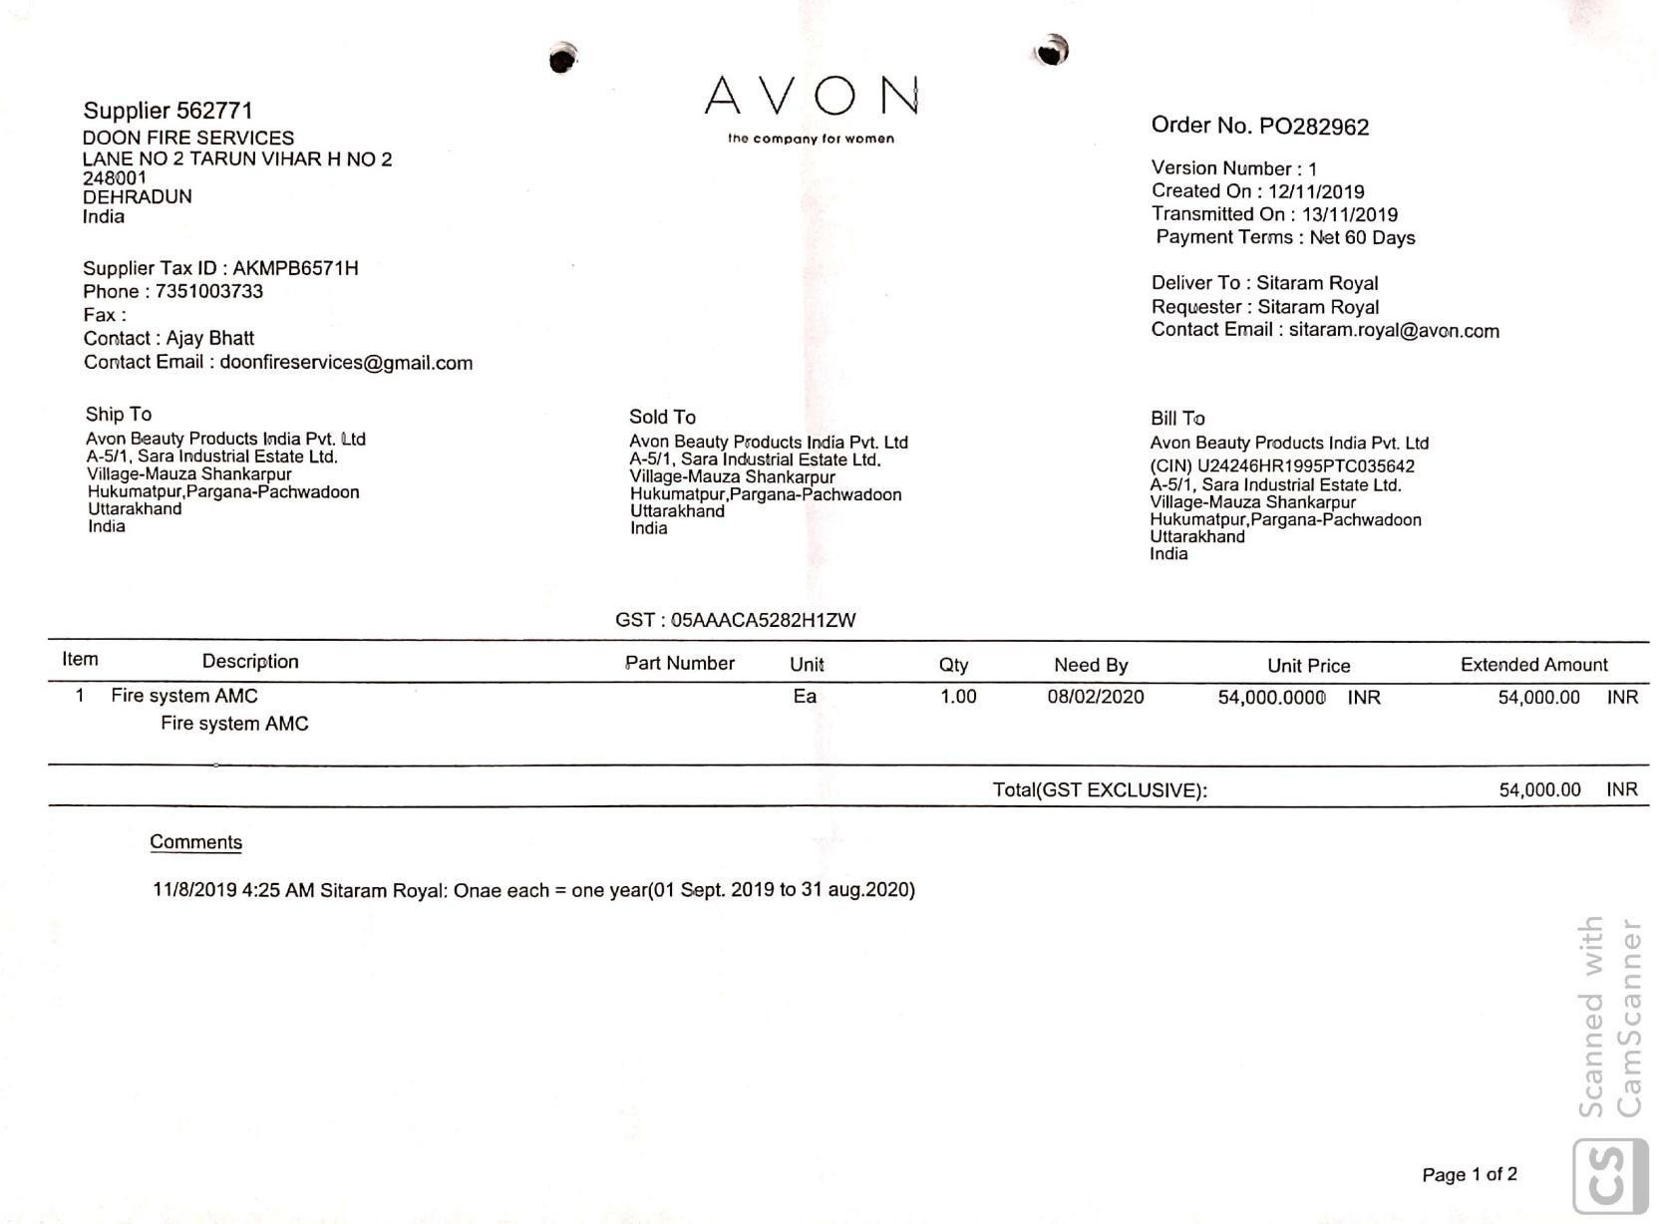

*(Afflicted to the Council for the ISCE. New Delhi)*

3/J Curzon {Nehru) Road, Dafanwala, Dehra Dan - 248 OOI, Llttarakhaod (tadln)

**Teteph0ae** : **(0135)** 2631805 **F•aczboile** *(0135) 2652426

**International dialling** code : + 91 135

Terms & Condition for Doon Fire Services:-

1. Payment 25% advance with purchase order, 25% after completion of pipe fitting, and the rest

-ofier the completion of the work.

1. Delay in payment and site 8fe not completed for work, It may be delay in completion time of the project.
2. The above mentioned quantities are estimated oniy.

Construction/ installation of underground water tank, terrace tank,p P• °^ ° @ fl O ther

4-

civil works are not in SCope of Doon Fire Service.

5. Store for material will be provided by the client.

1. Electric supply for welding machine or other equip< 29{ rO Vl ded by the clfen.t.

cost client has nO Tlgrt to Stop our tools to take out from *t2i• Sit • •y ti • f r •y

1. At any reason(S).
2. Electric supply for firefigb •8 P • l proc ided by the client.

9. wor k will start on site after five days of electing the advance paym e r-1t

1. NOC charges will be extra.

Fire NOC but si ng shou!d b

TT BOARD or

1. For obtaining

;jjjy othsr coiicern*

authority, we Will Hot

gFireNOC.



Mrs. h4 iju Grover

Princip al Fqqp

**GfoetdVn SnhoA**





|  |  |  |  |  |
| --- | --- | --- | --- | --- |
| t 1 | Supply of CO3 4.5 KG Refill |  | Nos. | 1 1770.00 **17T0.00** |
| 2 | Supply of ABC 4 KG Refill |  | Nos. | 1 1080.OO **1080.00** |
| 3 | Supply of DCP 5 KG Refill |  | Nos. | 580.00 **580.00** |
|  |  | Total |  | **t7140.00** |

,



**Uttarakhand Power Corporation LU.** (A €iow. of Uttarakhand Undertaking) **Execut\ve Engineer.**

**¥lectrtcity Distribution Divlslon (South),**

No (

/EDD(S)/A.S/

M/S Do on Flre Services

Bhatt Niwas, Tarun Vihar Lane.2

H.No.2 Mothrowala Road, P.O. Ban]arawala

**Dehradun.**

Subject: Supply of Refilling of Fire Extinguishers.

I

(Rs Twenty Seven Thousand One Hundred Forty Only)



Dear Sir,

supply o the following materials on the terms and conditions given below (refilling fire extinguishers)

Wilh reference to your quotation against enquiry no. 1305 dated 16.07.2019. We hereby place an order with you for the

TermsondCondlttons:

1. Pdces
2. **G.S.T.**

3. 8.D.R.

4. Delivery

: The rates quoted are firm and FIRM IN ALL RESPECT and will not vary during the currency of the order.

: Extra

: The rates Quoted ts **F.O.R.** Dehradun

* Smpty cylinder shall be Collected from concerning sub station with proper rece1ving and after refilling they shall hand over to same sub station under supervision of concern SDO/)E. The supply please may be handed over with 3 weeks.

contd ..,2

'

!

|  |  |  |  |  |  |
| --- | --- | --- | --- | --- | --- |
| N” PARTICULAR  33/11 KV Sub Station Turner Road, Dehradun | **UNIT** | **TOTAL** | | **RATE** | AMOUNT |
| 1 Supply of CO2 4.5 KG Refill | Nos. | 2 |  | 1770.00 | 3540.OO |
| 2 Supply of ABC 4 KG Refill | NOS. | \ |  | 1080.00 | 1080.00 |
| 33/11 KV Transport Nagar, Dehradun   1. SuppIy of CO2 4.5 KG Refili 2. Supply of DCP Refill   33/ 11 KV Urja Bhawan, Dehradun   1. Supply of CO2 4.5 KG Refill 2. Supply of Foam 9 Ltr. Refill   33/11 KV Vasant Vihar, Dehradun   1. Supply of COZ 4.5 KG Refill 2. Supply of ABC 4 KG Refill 33/11KV IHM, Dehradun 3. Supply of CO2 4.5 KG Refill 4. Supply of ABC 9 KG Refill t 33/11KV Xaulagarh, Dehradun | Nos.  Nos.  Nos Nos.  Nos. Nos.  Nos. Nos | 2  t 2  y  i  t z  t y |  | 1770.OO  sao.oo  1770.00  440.00  1770.00  1080.00  1770.00  1790.00 | 3540.00  1160.OD  3540.00  880.00  1770.00  1080.00  **3540.00**  **3580.00** |



€MPEROS IN FR ASYRVC TURE Pw, kTD )

rRou coMcEPT To cRzATion

Ref No: EIPL / DFES / 19-20

Saturday, July 28, 2Ol P

64/s Doon fire equipiiicnt services pvt ltd.

F-38 Uniyal Residency Teliri Nagar,Bangali Kotlii, DchraJun 248001 (U.K)

Kind Attn Projcct Subject

' k1t. Ajuy Dhalt

Rajpur Greens — Dehradoon

: fire fighting ’ork — \Vork order

Dear Sir ,

\Ve are pleased lo inform you that your company has been appointed to carry oul the abovc works based upon the final quotation submitted on 21.07.2019

Time being the essence of ltte project, you are hcreby directed to treat this letter as nolice to start mobilization & planning for ltte timely execution of project.

The terms & conditions of this work order, mentioned below, 'ill govern the contract.

1. Scope of works:

The scope of w’orks shall bC SUQQI , storage, 1iftinp•, shifling, installation, testing, commissioning & ll8l2ding over fire fighting work including fire hjdrant SjsteiT1, sprinkler system, portable chemical fire extinguishers, fire pumps, equipments, valuts R gtc, as per detailed design & df9ii'ings.The scope of this work shall consist of fire fighting





,$tt- Joseplj g,$rsbem uT-006 22 ° July, 2019

TO,

Er. Ajay Bhatt (Prop.)

Doon Fire Services,

Tarun Vihnr. Lane No 2, House No.2 Mothrowala Road , P.O. Banjarawala Deh modun - 248001

M.No. 9897574653

Subject Work Order for Installing Fire Fighting Systems

Please refer to onr discussion regard ing Fire Fighting Systems required in Our School Cann pus. VVe hereby informed you that the management finalized the quotations received and giving the opportunity to your institution for installing Complete Fire Fighting Systems in our school cam pus with the rates as agreed is mention below

Scope of wo rk:-

1. Fire Figlltir g System at Brothel s Residence \ Includ ing Fire Extinguishers)

1. Fme Fighting System at New MiddIe School ( Millennium Block)
2. F me Flgh ting System at JLinior School Building.
3. Flre F g!›ti ng System at Ne›'v Juniof School Building
4. Fme F igh(ing System at Adix Nnistrative Block (Bicentenary Block). G Fire Fighting System at Admin istrntive Block (Dooley Block).

7 Fire Fightin9 System at Heritag e and Auditorium Briilcling

1. Fii e F ig hting System at L K G and U K.G Block

The ”Total Cost of the above project is Rs 24,17,298/- (Rupees Twenty Four Lakh Seventeen Thousand Two Hundred Ninety Eigtst Only) excluding GST (Taxes).

Terms & Condi tions:

1. Bill tc be sencl in the Name of St. Joseoh 's Academy, Rajpur Road, Dehradun.
2. Our I rlstitrition is exe opted from GST Registration & Our PAN No. A ACTS9786It and TAN No. MRTT00290D

I *, Rajpur Road, Dehradun - 248. 00. 1, U«arakl and, li dia

Tel : *9 1 135 271207 I , 2712426, Mob : +9 I 7060I -02648, Fa.x : +9I 13S 2712644

\\’ebsite : vw\v,S(jos cphacademy .i n. e-mail : school office stjoscphacadem)‘.in

D‹itcd: I G/07/20 15

Builtech

o. 2, ’1“artin Vihal•,

P€J — [3anjarawnlii, Dehradun, Uttarakhand

of for fire protection work at our site

ehradun. "l’ei me and conditions are here lv

ease go ihr‹›itgh the work order and acknOWl°^ g e . Tc•rin A Conditi‹ins: -

oiiil I'm›jcct com Rs.225tlt)()§.()f) (ttq p«›x) + os r i 8% will be extru.

!’!*^^*- i — f’ipu wurk

I’h larm Wcrk

I l n1 sc-lil- Pjpc wc›rk - Valence

PhosO-j \ / - I fydrnnt work

Pha50- \/- Qty p '‹• *•‹ixguishers.

Scanned %,

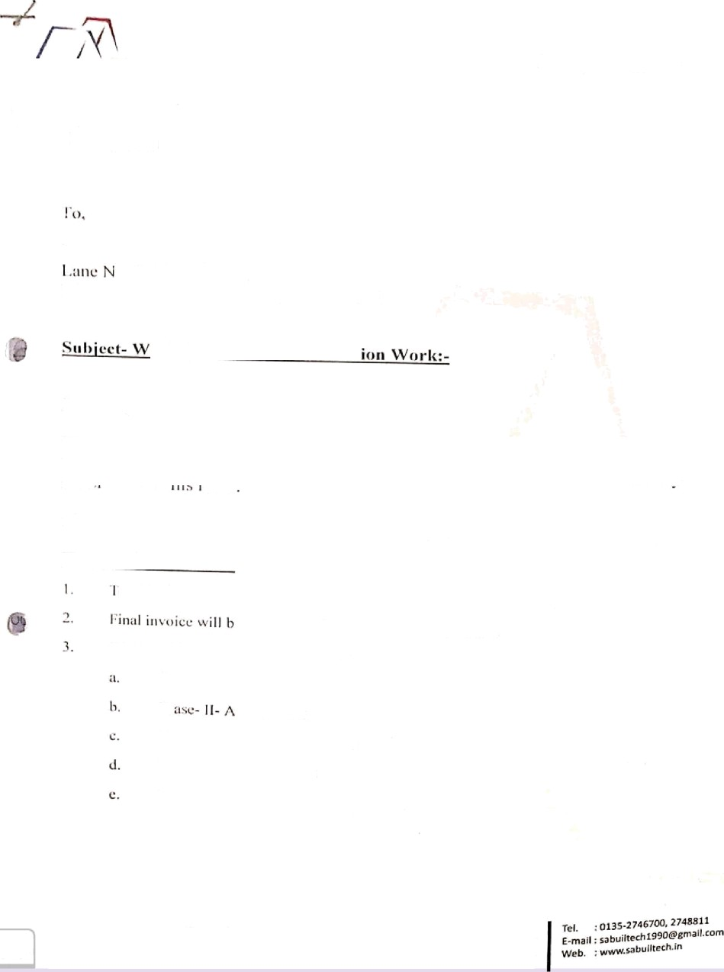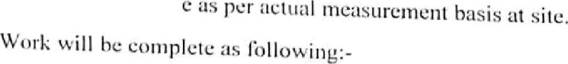

Ca m S ca n n e r

’ +*¥ •* to. Dehradun-z48001 {us)

”• ’* lot No. 12, New OeIhl-t10075



PurMase Order No.:

-

 Deer Sir, PUftCHASE OROER

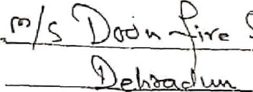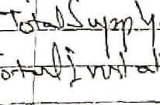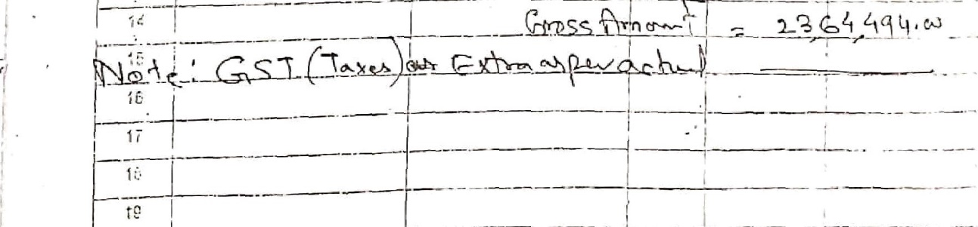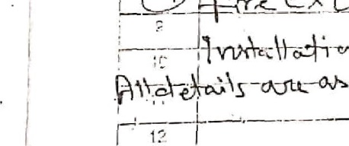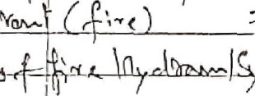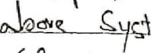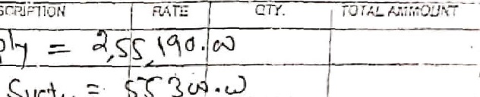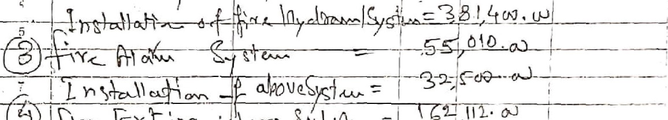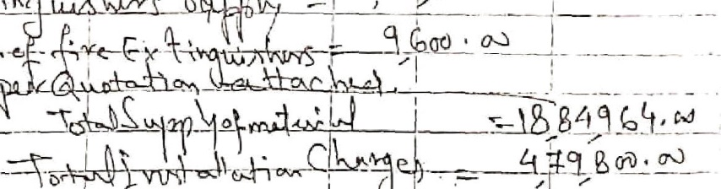

&

1?.

.

Sciinlied by CiirnScaHnei

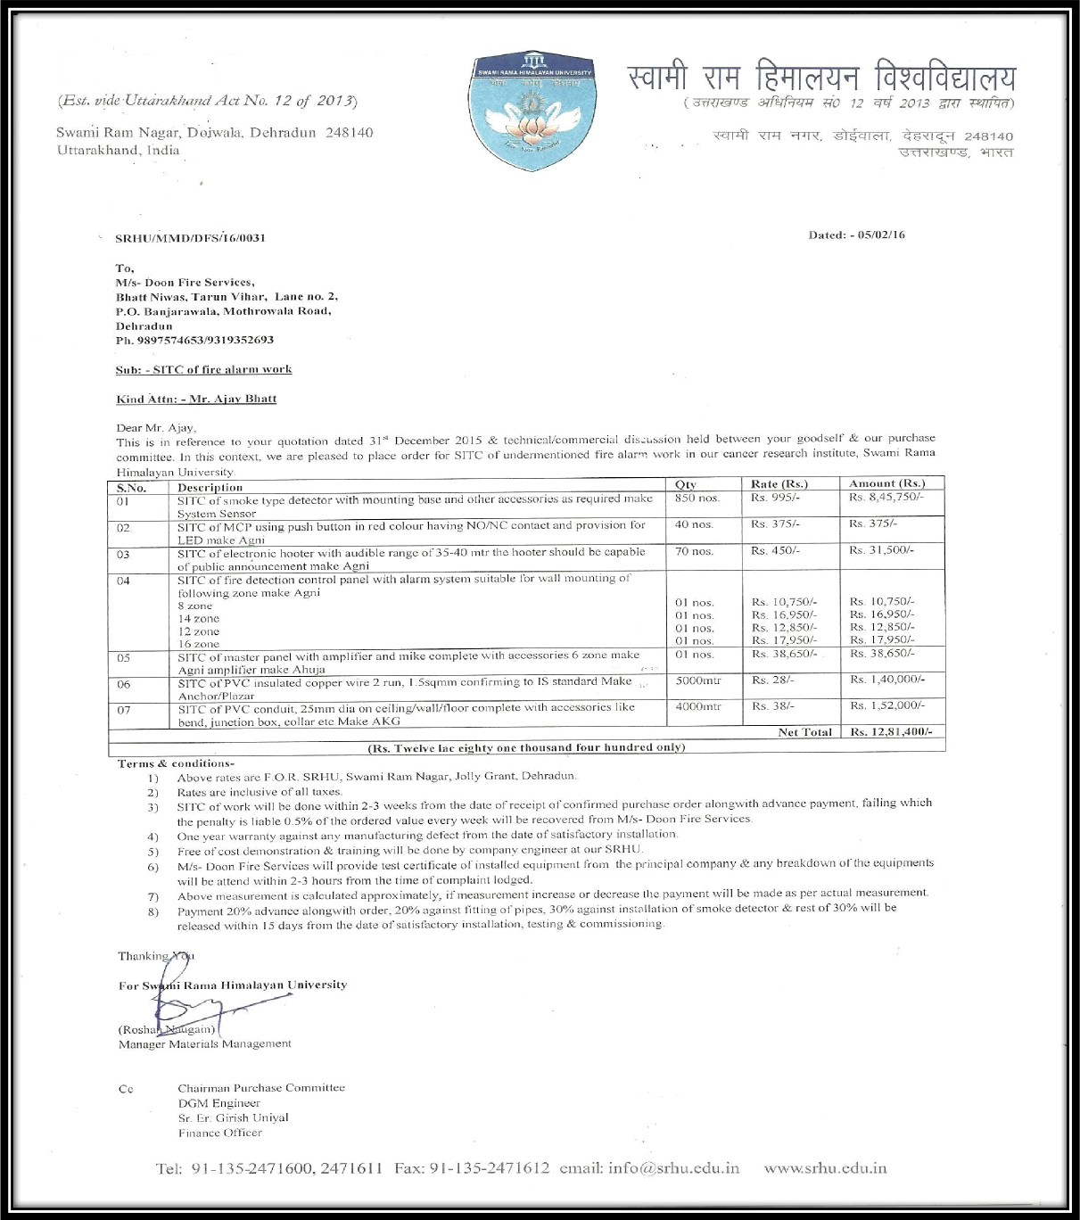

Swami 9omo Himoloyon University

' 1 2 3 5 6

|  |  |  |  |  |  |  |
| --- | --- | --- | --- | --- | --- | --- |
|  | 1 | i.00 | nos | SITC Of Fire Motor Pump 15 HP | nos | 1,13,275.00 ,I |
|  |  | 6.CO | mtr | SITC Of R.R.L Hose 1S mtr Long | mtr | 8,190.00 , |
|  | 3 | 1.00 | nos | SITC of Auto - Manual Control Pannel | nos | 30,000.00 ; |
|  | 4 | 20.00 | mtr | SITC Of Aluminium Armored Cable 4C X10Sqmm | mtr | 297.00 |
|  | 5 | 4.00 | mtr | SITC Of MS B Class Pipe 25mm | mtr | 576.DO |
|  | 6 | 6.00 | mtr | SITC Of MS D Cla ss Pipe 80mm | mtr | 1,756.00 |

-/ 8

9

n

11

12

13

14

1.5

C 1 £i

17

GB 19

— zc

( 21

22

23

:24

t25

26

120.00

3.00

3.00

3.00

2.00

' ^^ 1.00

2.00

1.00

1.00

2.00

1.00

1.00

too.00

1.00

1.00

4.00

100.00

1.oo

2.oo

mtr nos

nOS

nos nos nOS LiOS

nos nos nos

r\OS nos nos mtr 8 * FIOS

job mtr nos

nos

SITC Of MS B Class Pipe 100mm SITC Of Landing Yalve (SS)

SITC Of Short Branch Pipe Noozle [SS)

SITC Of MS Hose Box

SITC Of Hose Reel Complete Set SITC Of Ball Valve 25 mm SITC Of Two \Vay FBIC

SITC Of Air Release Val\ie 25mm SITC OF Pressure Gauge

SITC Of Butterfly Valve 80mm siTC Of Butterfly VdlVE' 100InfT\ SITC Of Non fteturn Valve 100mm

SITC Of Brass Body Foot Valve 100mm

SITC Of Wrapping Coating Tape 3mm SITC Of Pressure SwitCh

SITC 0f Tank Nipple 65mm

R.C.C Core Cutting Digging Work

SITC Of Fire Alarm Pannel 4 Zone SITC Of MS Body Hooter

mtr nos

nos

nos nos

nos

nos nos nos nos nos nos nos mtr nos nos job mtr nos nos

2,029.00 !

9,000.00 ’

3,770.00

5,980.00 :

1Z,870.00

1,390.00

8,980.00,

3,840.00 |‘

1,860.00 /‘

6,900.00 ‘i

7,900.00

8,160.00 ]

8,150.00

750.00 ‘. _ 5,650.00 t 1,600.00 1,500.00

250.00 , 26590.00' 1,045.00

27 2.00

nOs

SITC Of Mannul Call P0Int

nos | 940.00 ,

U

(a! 28

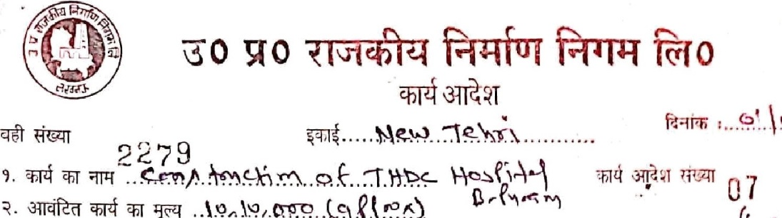

129

igo.oo

20.oo

mtr

mtr

SITC Of Copper Wire 1.5sqmm SITC Of PVC Conduit PipF- COMM Fire Extinguisher ABC Type 4 KG

mtr | 63.00 , * h

nos | 3,625

gay t 9,5t500

Ofk b

DoonF%Sawes

bhaRNiwas.LanB-2,TarunVihar. H.No.2,Near Uttaranch.ml Gramin Bank, I\1othro vala Road, P.0 banjara›yala, Dahraduti- 2480D1 (Ultarakhand)

uSTlMlJlN. 05AKLtPB6S71H1Z5

PAN TO. AK\\P665/ IH

Ccrti5ed :- ISO 9001:2015

Contact Person - L1r. Ajay Bhatt Contact No : 09897574653

Sub: uotation For S.I.T.C. of Fire Fi htin Work :-

\/for Or er Oate :

From : /\MAYA RESORT

Name of contact person:- SANJAY P‹iiWAR

Conlact No : 8958666626

GSTIN/UIN: 05ALTPP6067A1ZX

PAN NO: ALTPP6067A

Pump

Description

Rate

Total Rate

TEFC motor Of 15 HP App with Speed of 2900RPM and complete.

Meke : KirJoskar / Mather & Platt / Lubi

5upp!y# I staflgtlO0, testing and commissioning of Start Belta starter

*filth suttBble* MCB and w1th ali fittin

65,0D0.00

17,500.00

65,000.00

17,So0.0o

the rables as *follovzin*

Make: Hazells/ Polly cab / Gloster

*4c X* 105q.mv ror main pump.f aluminum armored)

Total (A)

Rmt. 20

170.00

3,400.00

Riser

*IOO*ITi*m* dia

S0mm *dia*

Apolo /E§ iV ,¿

.30

RM RM

1075.00

560.00

269.00

*7.00*

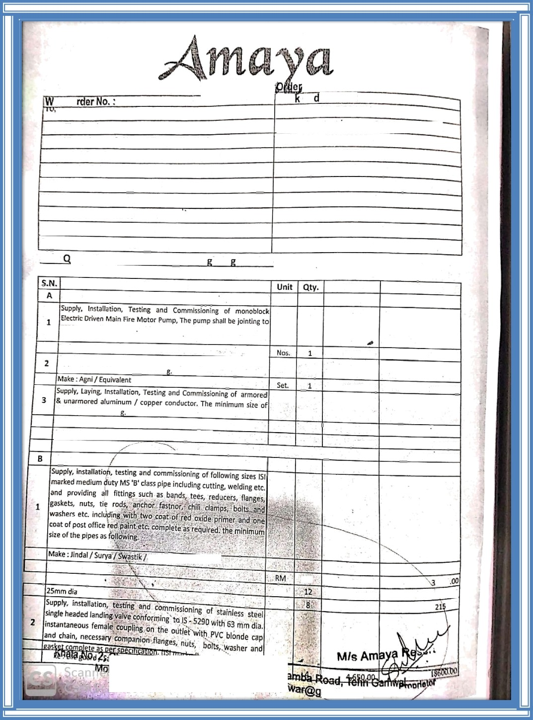

e E- I{!: sanzg pan mail.com

/SP0/2019

-24 8 0 0 ( )

DOON **UNIVERSITY**

Mothrowala Road Kedarpur, P.O. Defence Colony,

Deh radun-24800 1 (Uttarakhan d) INDID•

D i : Jg Novembe r 2019

M/s Doon fire Services Bhatt Niwas, Tarun Vihar Lane No.2, Mothrowaia Road Dehra‹1un - 240001

E-mail:- t1oonfireservlcesHflmai!:cent.

**Sqb: Refilling of Fire Extinguishers.**

1. Refer to your Quotation no.-DFS/DU/2019-20Date8: 28.10.2019.
2. *Please* provide us the following items:-

|  |  |  |  |  |
| --- | --- | --- | --- | --- |
| Sr.No. | Description of items | Qty | Rate | Amount |
| 1. | Refilling of Fire Extinguisher ABC 2 I(g | 06 | T 370.00 | I 2220.00 |
| 2. | Refilling of Fire Extinguisher ABC 5 Ing | 3S | T 525.00 | T 183 75.00 |
| 3. | Refilling of Fire Extinguisher C02 4.5 | 33 | 1 445.00 | I 14685.00 |

1. llefilling of Fri e Extinguisher C02 22 01

1(g

5. Refilling of Fire Extinguisher BCP 5 Kg 36

I 1380.00

I 540.00

Total

T 1380 00

T 19440.0 0

T 56100.00

GST@10 % extra

OneRu ee si t si h us n one **hun**n**d**d**r**re**ed** i e

T 1 0098.00

**G. Total T 66198.00**

e ht on

**GST I nclusive**

CO diti a e as f I S

. The firm will Sq pply the above items to U n lver

Campus

* 1. Payment wilt be m de

sity

of th is University.

items.

* 1. Q CaSe ally

d to the

*> after com ple te suppty and installatio

n of above

Chanc l1»r,

°°e P° FlCies a nd problem, ih‹

DO f l Univers it y. D£l hr adun

Br OCe e8i ngs will be made to the Vice Whose

accepta ble to all.



decisio n would be final and





”PVT

TIN NO.

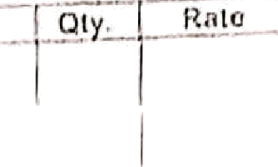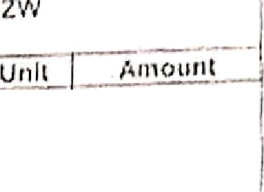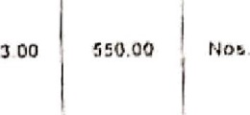

LAHB NO. 1

P.O. t3PkJAltAW*W. I\tOTHROWAW ftOAD

D»l lvory

NUT R ACEUTICJ\•L6 PVT LTD

j|jg]$l|gtion ta+tIn0 -incl

class pipo ii›ciud'n9 ^^!""

RN

Ia00D.00

Ayr\tt clifiin i\•iccscUly companion







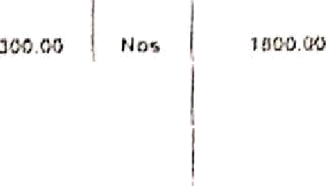

2 g0 1y60.00 t Noc 1 250b 00



 

Make Soo6d Kar•ar Ccsj*e / E4urYsJen1



Scanned with CamScan ner

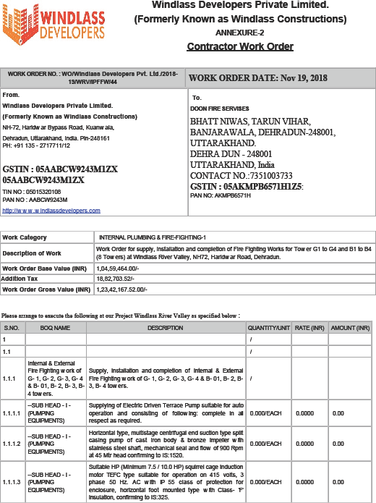

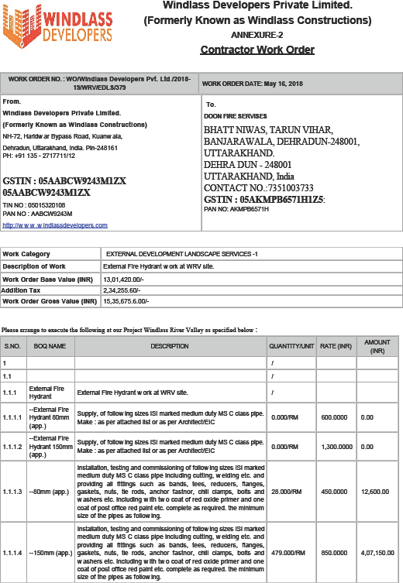

Shri Guru Ram Rai Institute of Medical & Health Sciences

###### Shri Mahant Indiresh Hospital Patel Nagar, Dehradun — 248001

RzSNo.SGRRHflBS/PO/P/62WI0f8M9

Date: 17.07.2017

Doon Fire Services

Mothorowala Road, Tarun Vihar,

Dehradun, Uttarakhand 248001

Mob: 9897574b53 Email: doonDreserviees ,gmail.com

Dear Sir,

With reference to your quotation dated 30.06.2018 the subsequent discussion in the matter, please supply the following items as mention below.

**Material Description**

**Fire & Safety Work at PG College** New building

@aeeosezzt+Gd+1“ +2“ -i-3 -I-4 )

**Note: Detail Description of the** worL **as per your quotation dated 30.06.2018** (Copy **attached herewith)**

**Total amount Rs. Eighteen Lac Fifty Thousand Only.**

9teéee Note tbe £oftowizsg learns A cozsditiozs of tbe Order:

**1 LOt 18,50,000/- 18,50,000/-**

Total | 18/0,000/-

or«»a z«t»i I ia,so,o ow-

l.Total value of the order is **Rs. 18,50,00Of- (As. Eighteen Lac** Fifty thousand Only) on delivered basis excluding

GST.

1. Guarantee Period: One year from the date of installation. 3.All Equipment should be ISI Mark and as per finai meeting.
2. Equipment will be check by engineers and FSO before installation.
3. Al1 work should be complete with time period co-ordination.
4. All work will be completed with required panting, finishing and testing. 7.All disputes are subject to jurisdiction of Dehradun.

8.Payment: 50% advance and 50% after successful installation through RTGS.

I'4nte: The final payment will be done only after actual measurement of pipes, material and completion of work subject to verification by concern department.

Civil Engineer (SMIH)

CC: Finance, Siore, PG College.

SMIIg

**Vice** Cbazscel1or SGRIt Uasiversity

**RRNWHS**

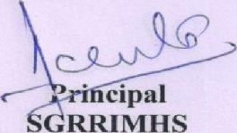

Purchase ailment Ph. No. (0135) 6672573, 2522250, 6672698 E-mail: ,purchaee€beqrrmc.com Wekaito: .agrmsc.com

H capital Phonea: (0135) 15221oO, Z5ZZ2OO, 6672562, 8672808. Emergency No. 25223oQ, 6672600, 272810B, Fax: (0135) 272D151

Medical College phonea: 1522108, 2622110, 25Z211B, Fax: (0135) 2522117 E-mail: sml hQBDlcalEBnmall cOm

oon Fix Serviccs,

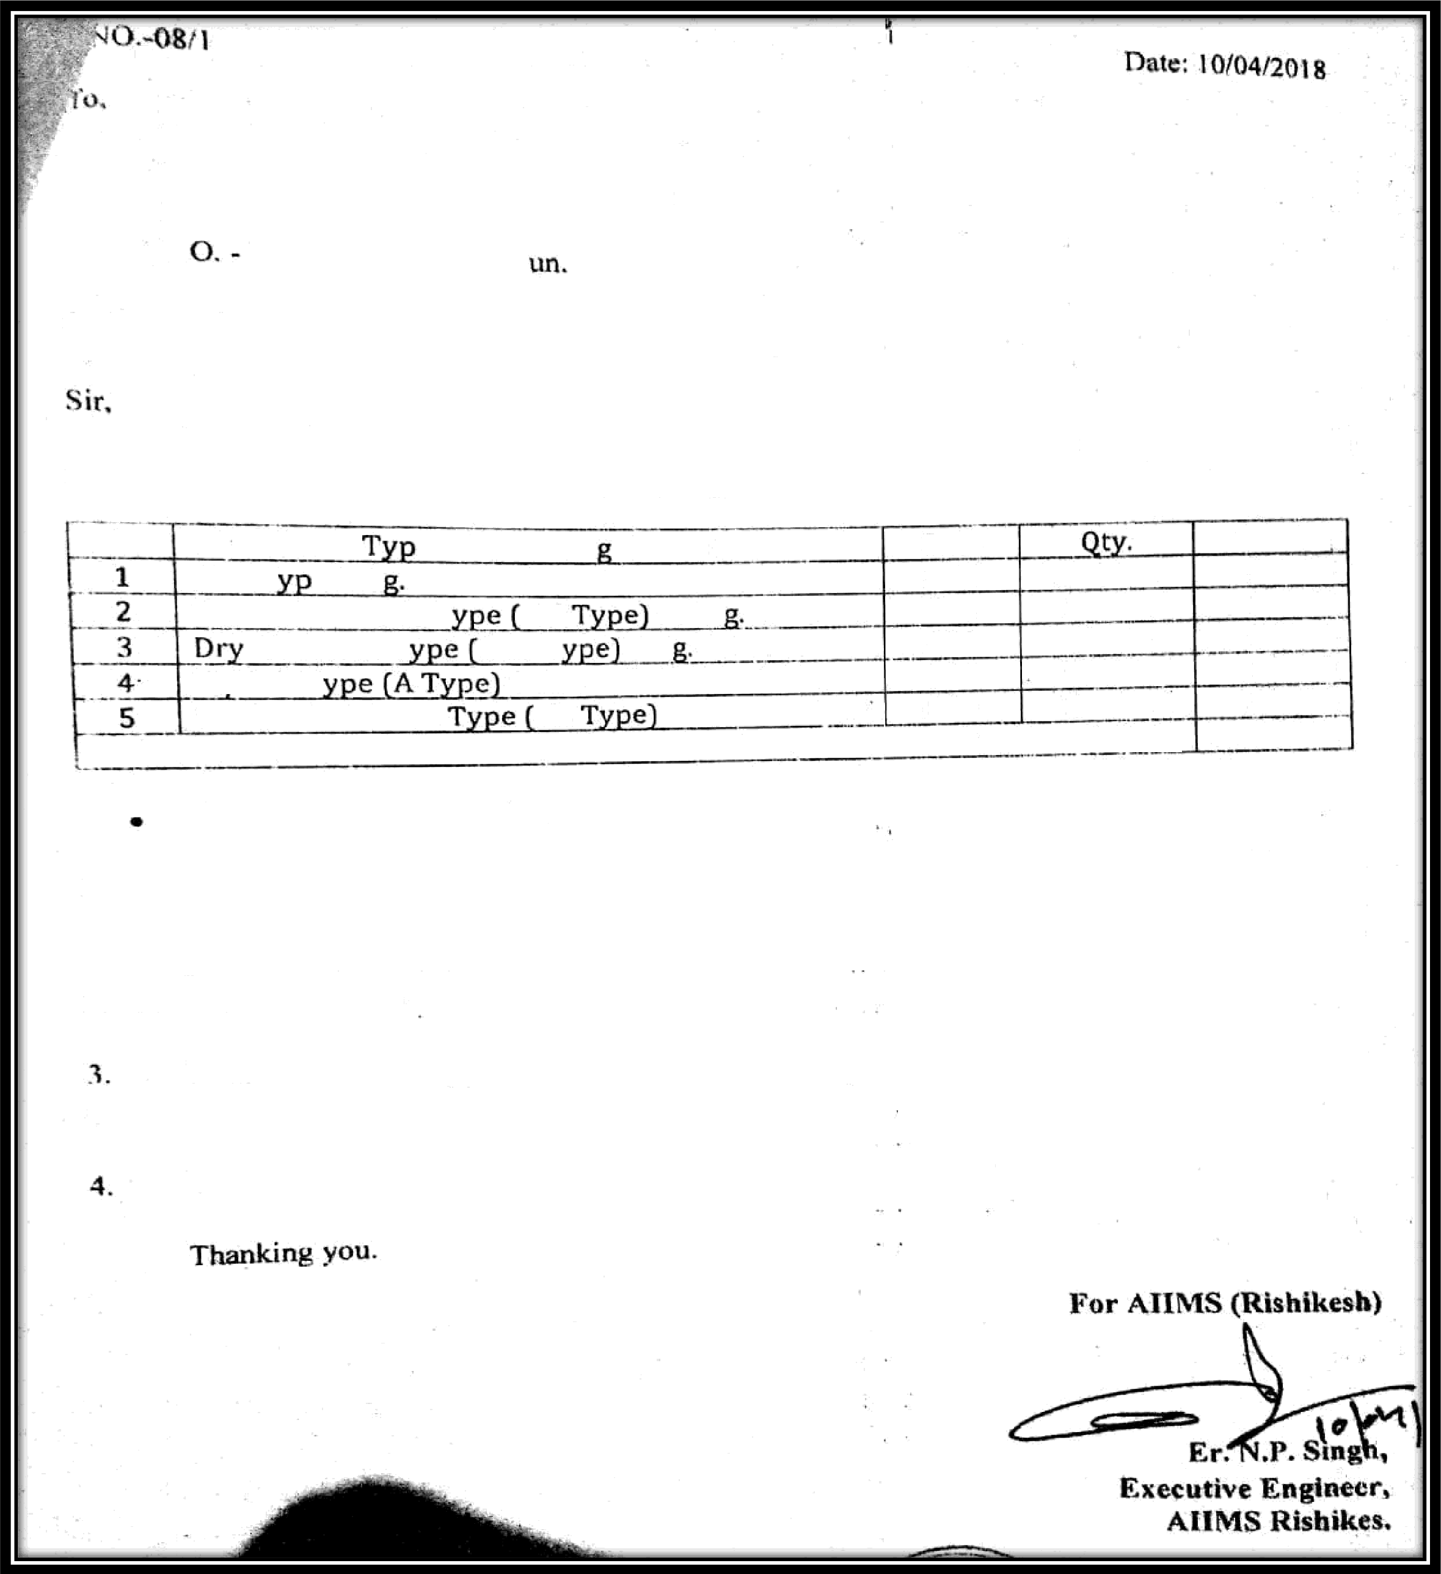

Bhatt Nizas, Tarun V ihar. Lane No.-2, House to.-2.Mofhrowala Itoad.

Hanjarawa la, Deliiad

**Subject:** Work ^ ^’ * < <^ •!ttng of 252 **fire extinguishers.**

tlnd wui k Order I th- refilling work ‹›t” lire extinguishers as per rate quotad by you in Muted 02.01.20 I ft. ’FI c detai Is nrg given below: -

si.

e of fire extin uishers

ABC T e 2 K

Carbon Di-Oxide T B C 4.S K

Chem ical T D CP T o X

W/Co2 T 9 Ltr. Mechanical Foam AB 9 Ltr.

Rate Total

520 10B No. 56160

800 16 No. 12800

‹ss0 49 No. 31850

800 42 No. **

a00 37 No. 29600

Total amoun t = 164010

GST extra a-s per appI1cab1c.

1. Since req uirement is urgent. you are requested to ai range to supply thc above said iterrts at

cii MS. Rishikesh promises at the ndersigned for mak ing payment tisféctu * csf’ the wo °k.

earliest and send pre-receipted

ot“ bill. The cheque/pa yment

bill in triplicate together to the

shall fie released only after

Defecting WOFk will not be accepted, AIIMS. Rishikesh reserves the right tñ reject the wo r k

order if WOPk tound unsuitable.

Wom k should be done within 7 days from issuing of work order.

# AMC & CAMC PURCHASE ORDERS

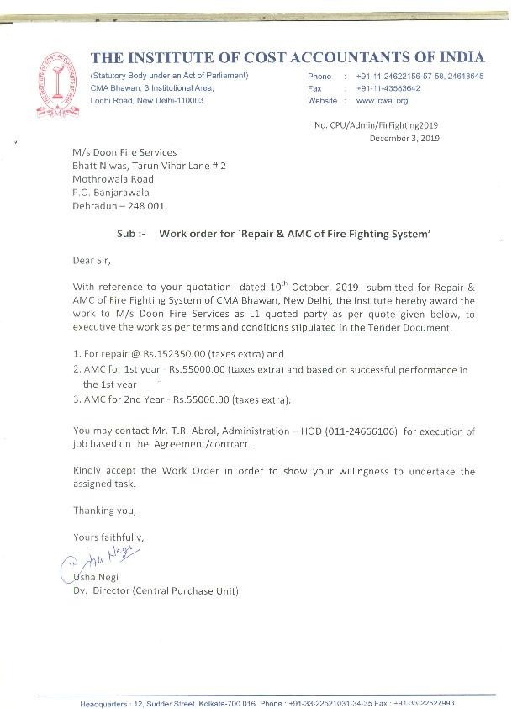



Guru Ram Rai Institute of Medical & Health Sciences Shri Mahant Indiresh Hospital

Patel Nagar, Dehradun - **248 001**

**Ref.** i'4o. **SGRRIMHSfCAMC/062/2017-18** Date: **01.05.2017**

Doon Fire Services

Bhatt Niwas, Tarun Vihar, Lane no. 2,

P.O BanjarawaIa,Mothrowala Road,

**Dehradun** - 248001

**Mob. 9897574653 Email: noonfireservices**aUginuil.com

Sub: Approval of CAShe i e E e CAMC Period 1“ May 2017 to 30 April 2018

* 1. Refer to your proposal for **CAMC** bearing case mark nil rated 14 April 2017
  2. Your Proposal, if›*d for CAMC of fire safety equipments mentioned below. is here by accepted.

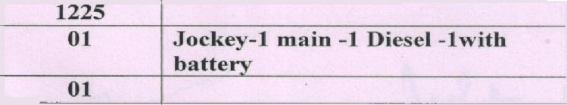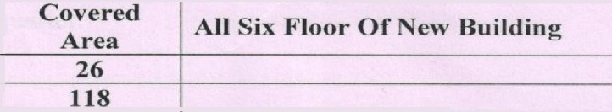

|  |  |  |  |  |
| --- | --- | --- | --- | --- |
| **S.No.** | **Name of the Equipment** | **Qty** |  | **Remarks** |
| **1** | **Hydrant Complete** | **86** | | | **With Hydrant Line Ring** |
| **2** | **Four way** | **01** | | |
| **3** | **Hose Reel Complete** | **65** | | |
| **4** | **Sprinkler System** | Covered  **Area**  26  **118** | All Six Floor Of New Building | |
| **5** | **Alarm Panel** |
| 6 | MCP with Hooter |
| 7 | Smoke Detector All Type | 1225  **01**  01 | **Jockey-I main -1 Diesel -lwith batte** | |
|  | **Pump Set Complete** |
| 10 | Pump Room Panel |
| 11 | Alarm main Panel | 01 | | |
| 12 | E’ire Estizxguieber | 320 | | |
| **Total Azaount {Anzsuaftv Mode}** | | | **5,76,000/-** | |
| **Service Tax** | | | **Exempted** | |
| **Grand Total**  **Total Amount Rs. Five Lac Severity Six Thousand Only.** | | | ) **5,76,000/-** | |

* 1. Tenure of the contract shall be one year from the date of its commencement and with the following terms and contestations:-
     1. Replacement of spare parts whenever required shall be original and shall be meeting the norms of the Institute..
     2. All Fire extinguishers shall be maintained properly and shall be painted annually by the company. All the extinguishers shall be refilled **at SMIH** Hospital only except CO2 (Carbon di Oxide).
     3. A trained fire technician for the purpose shall be provided by the company for continuous 08 (Eight) hours from 9AM to SPM who shall be in possession of necessary tools to undertake maintenance of fire equipments/gadgets
     4. Fire technician deployed in the institute shall always wear identity card issued by the company while on duty. Similarly, the company shall submit identity proof containing local address of the technician, to security department of the institute.

Contd..2

**Hospital Phoneg** .: **(0135) 2522100, 25zz200, 6672400, 6872562,** 6672809, Emerpancy No.: 2522300, 6672600, 2728108, Fax : (0135) 2720151

**•! f'••!IeBe Phonea** : **252Z108, 2522110, 25221J6,** Fax : (0135) 2522117 E-f¥¥sII : [smi.hospitd@gmail.com](mailto:smi.hospitd@gmail.com) Website : .sgrrmc.com